**Conditional Operator in Assembly language**

**LAB # 04**



**Fall 2021**

**CSE304L Computer Organization & Architecture**

Submitted by: **Ashfaq Ahmad**

Registration No: **19PWCSE1795**

Class Section: **B**

Student Signature: ______________

Submitted to:

**Prof: Ammad khalil**

December 8, 2021

**Department of Computer Systems Engineering**

**University of Engineering and Technology, Peshawar**

**Objectives:**

* To know about the Conditional operators in Assembly language (beq,bgt etc).

**Task 01:**

Write a program that take two integer and if 1 is input it will display their sum and if 2 is input it will display their Subtraction.

**Source Code:**

.data

str1: .asciiz"Please! Enter First NO:"

str2: .asciiz"Please! Enter second NO:"

str3: .asciiz"Please! Enter 1 for addition or 2 for subtraction:"

str4: .asciiz"The Result is: "

.text

main:

li $v0,4

la $a0,str1

syscall

li $v0,5

syscall

move $t0,$v0

li $v0,4

la $a0,str2

syscall

li $v0,5

syscall

move $t1,$v0

li $v0,4

la $a0,str3

syscall

li $v0,5

syscall

move $t3,$v0

li $t4,1

beq $t4,$t3 addationlabel #(branch_if_equal_to) if t4 and t3 equal it will perform addition.

#we can also manage this task using bgt but beq is more suitable

sub $t5,$t0,$t1

j exit

addationlabel: add $t5,$t0,$t1

exit:

li $v0,4

la $a0,str4

syscall

li $v0,1

move $a0,$t5

syscall

li $v0,10

syscall

**Output:**

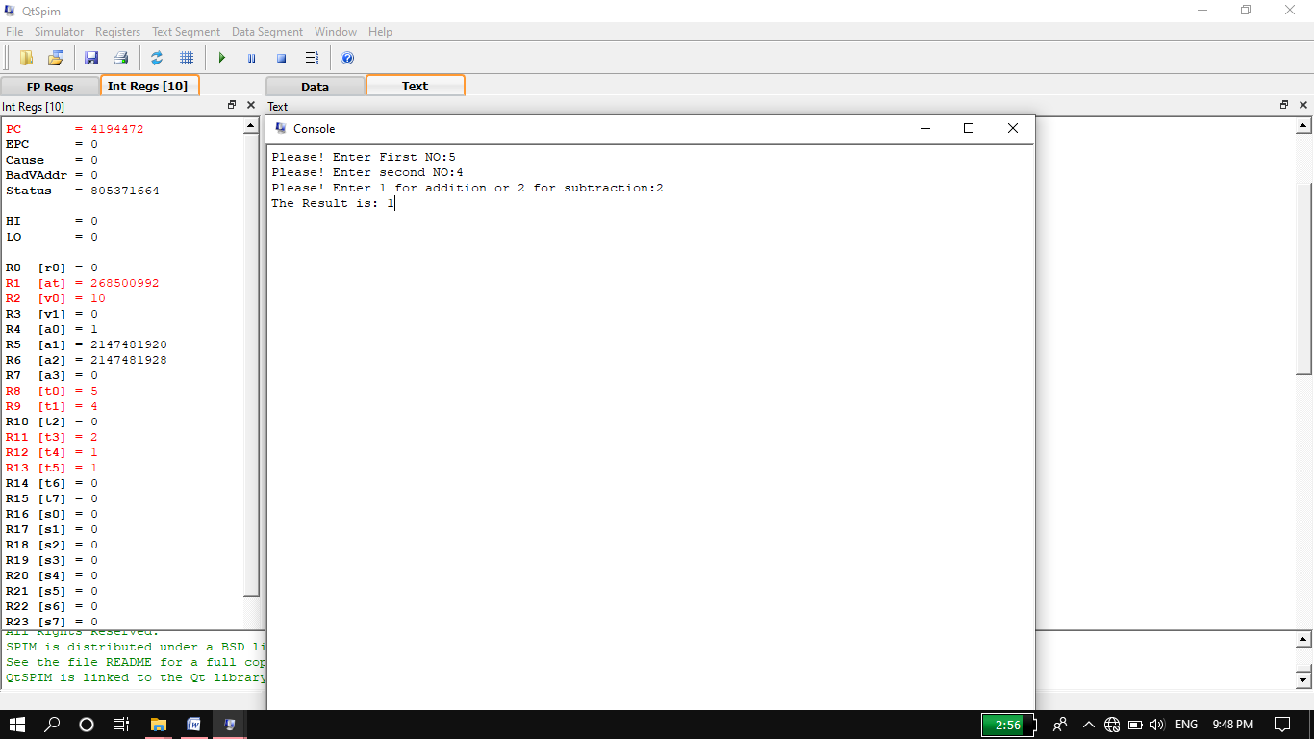

**Task 02:**

Write a program that take a number and then display its last digit.

**Source Code:**

.data

str1: .asciiz"please Enter the number:"

str2: .asciiz"The last digit of input number is:"

.text

main:

li $v0,4

la $a0,str1

syscall

li $v0,5

syscall

move $t0,$v0

li $t1,10

div $t0,$t1 #if we divide by 10 last digit will always reminder it will store in high register hi.

li $v0,4

la $a0,str2

syscall

li $v0,1

mfhi $a0 #we will move last digit or reminder to a0 register for display.

syscall

li $v0,10

syscall

**Output:**

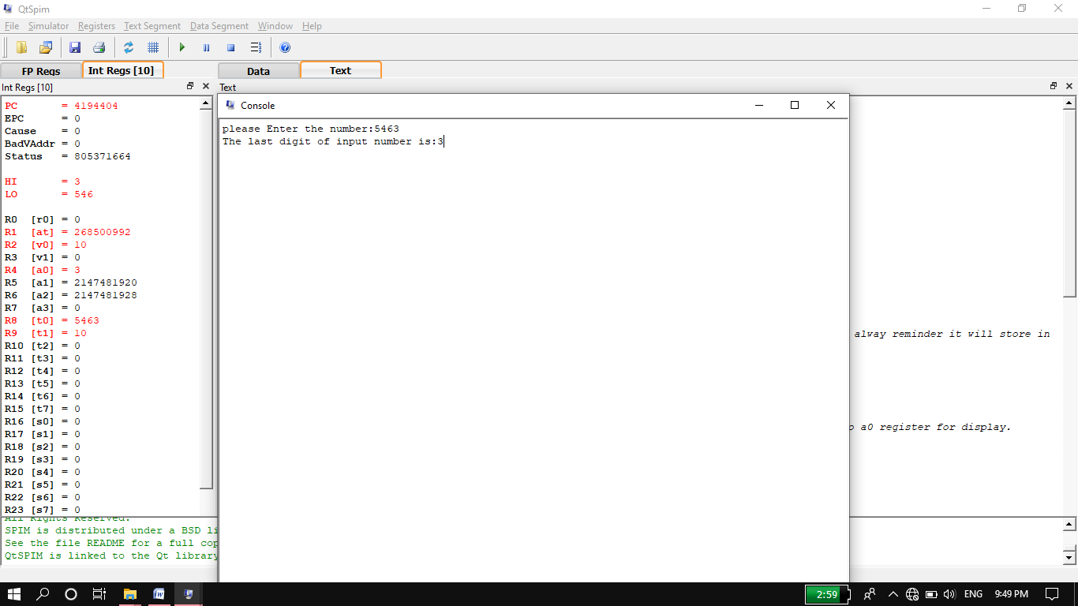

**Task 03:**

Write a program that take a number and display its 7th bit.

**Source code:**

.data

str1: .asciiz"Please! Enter an integer of 7 bit:" #each register store integer in the form of 8 bit.i,e 3=00000011

str2: .asciiz"The 7th bit of input integer is: "

.text

main:

li $v0,4

la $a0,str1

syscall

li $v0,5

syscall

move $t0,$v0

li $t1,0

li $t2,1 #if condition true we will display t1 otherwise we will display t2.

li $t3,64 #we will "and" input number t0 with 7 bit integer 64.

and $t4,$t0,$t3 #we can't put 128 here directly.

beq $t4,$t1 label #branch_if_equal i,e it compare t4 and t1 if they are equal then label statement will execute.

move $t5,$t2 #we can't move t2 to a0 here directly.

j exit

label: move $t5,$t1 #we can also move t4 to t5 instead of t1 because if conditon of beq true t4 will contain 0.

exit:

li $v0,4

la $a0,str2

syscall

li $v0,1

move $a0,$t5

syscall

li $v0,10

syscall

**Output:**

**7th bit 1:**

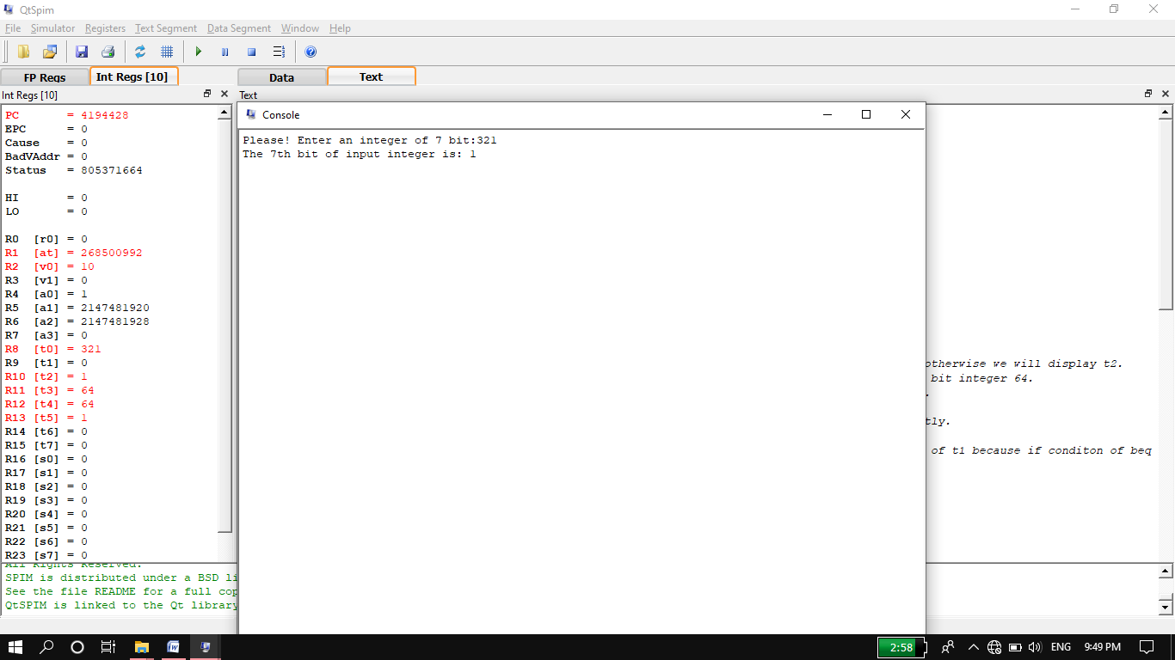

**7th bit 0:**

